Monoalphabetic Cipher
Aim
To implement the Monoalphabetic Cipher algorithm in C for encryption and decryption of a message.

Algorithm
- Start the program.
- Enter the plaintext message (uppercase letters).
- Enter the substitution key (26 unique uppercase letters).
- For encryption, replace each plaintext letter with its corresponding letter in the key.
- Display the encrypted message.
- For decryption, replace each encrypted letter with its corresponding original letter.
- Display the decrypted message.
- Stop the program.

Program:
#include <stdio.h>
#include <string.h>
int main()
{
char plain[100], cipher[100], decrypt[100];
char alpha[] = "ABCDEFGHIJKLMNOPQRSTUVWXYZ";
char key[] = "QWERTYUIOPASDFGHJKLZXCVBNM";
int i, j;
printf("Enter Plain Text (UPPERCASE): ");
scanf("%s", plain);
// Encryption
for(i = 0; plain[i] != '\0'; i++)
{
for(j = 0; j < 26; j++)
{
if(plain[i] == alpha[j])
{
cipher[i] = key[j];
break;
}
}
}
cipher[i] = '\0';
printf("Encrypted Text: %s\n", cipher);
// Decryption
for(i = 0; cipher[i] != '\0'; i++)
{
for(j = 0; j < 26; j++)
{
if(cipher[i] == key[j])
{
decrypt[i] = alpha[j];
break;
}
}
}
decrypt[i] = '\0';
printf("Decrypted Text: %s\n", decrypt);
return 0;
}

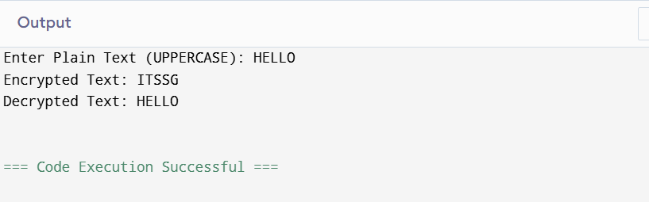
Result:
Thus, the Monoalphabetic Cipher was successfully implemented using C, and the plaintext was encrypted and decrypted correctly.

